Interfaces

📌 Definition:
# Source: AI Source: Provided by: [Data Path: Persons Table -> ID Column: 1, Name_En Column: Motasem Essam] -> From: [Chatgpt (GPT‑5 Mini)] on [12/9/2025]
An interface is a contract that defines a set of methods that a class must implement, without providing their implementation.

🧠 Simple idea:
# Source: AI Source: Provided by: [Data Path: Persons Table -> ID Column: 1, Name_En Column: Motasem Essam] -> From: [Chatgpt (GPT‑5 Mini)] on [12/9/2025]
Interface = “What to do, not how to do it” 📜

🔍 Key characteristics:
# Source: AI Source: Provided by: [Data Path: Persons Table -> ID Column: 1, Name_En Column: Motasem Essam] -> From: [Chatgpt (GPT‑5 Mini)] on [12/9/2025]
- ❌ Cannot create objects directly
- 📌 Contains method declarations (no implementation)
- 🔗 Classes implement interfaces
- 🔄 Supports multiple inheritance (a class can implement many interfaces)
- 🧩 Helps achieve abstraction

📌 Example (Java):
# Source: AI Source: Provided by: [Data Path: Persons Table -> ID Column: 1, Name_En Column: Motasem Essam] -> From: [Chatgpt (GPT‑5 Mini)] on [12/9/2025]
Interface:
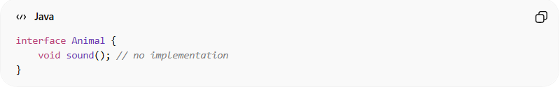
interface Animal {
void sound(); // no implementation
}

Class implementing interface:
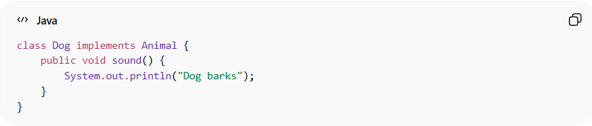
class Dog implements Animal {
public void sound() {
System.out.println("Dog barks");
}
}

Usage:
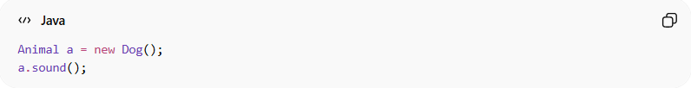
Animal a = new Dog();
a.sound();

⚙️ Why interfaces are important:
# Source: AI Source: Provided by: [Data Path: Persons Table -> ID Column: 1, Name_En Column: Motasem Essam] -> From: [Chatgpt (GPT‑5 Mini)] on [12/9/2025]
- 📜 Define clear contracts
- 🔄 Enable multiple inheritance
- 🧩 Promote loose coupling
- 🧠 Improve flexibility and scalability

🆚 Interface vs Abstract Class:
# Source: AI Source: Provided by: [Data Path: Persons Table -> ID Column: 1, Name_En Column: Motasem Essam] -> From: [Chatgpt (GPT‑5 Mini)] on [12/9/2025]
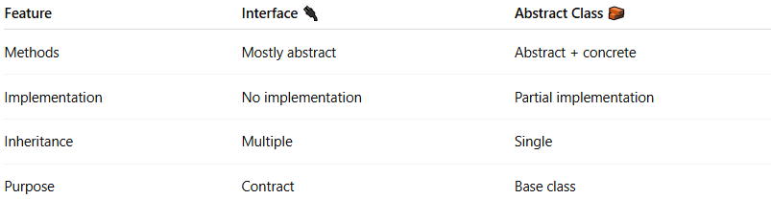
Feature | Interface 🔌 | Abstract Class 🧱
Methods | Mostly abstract | Abstract + concrete
Implementation | No implementation | Partial implementation
Inheritance | Multiple | Single
Purpose | Contract | Base class

🎯 Summary:
# Source: AI Source: Provided by: [Data Path: Persons Table -> ID Column: 1, Name_En Column: Motasem Essam] -> From: [Chatgpt (GPT‑5 Mini)] on [12/9/2025]
Interfaces define a contract that classes must follow, enabling abstraction, flexibility, and multiple inheritance in OOP.

